7) Given a 3D-object as shown below: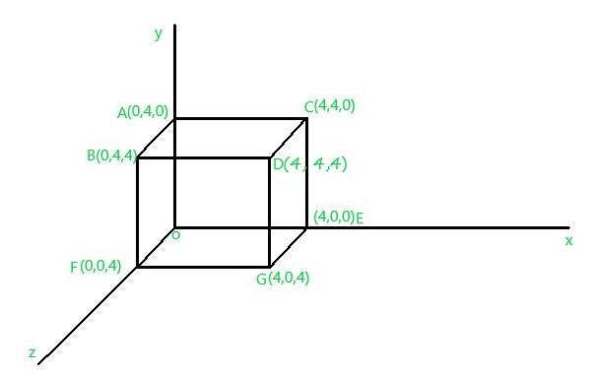

Perform Scaling transformation on the following figure where the given translation distances are Sx = 2, Sy = 4, Sz = 6

**Program in Python :**

import numpy as np

dimensions = np.array([[0,4,0],[0,4,4],[4,4,0],[4,4,4],[4,0,0],[0,0,4],[4,0,4],[0,0,0]])

s = [‘A’,’B’,’C’,’D’,’E’,’F’,’G’,’H’]

Sx = 2

Sy = 4

Sz = 6

a = []

a.append(Sx)

a.append(Sy)

a.append(Sz)

for i in range(len(dimensions)):

for j in range(len(dimensions[0])):

dimensions[i][j] = dimensions[i][j]*a[j]

for i in range(len(dimensions)):

print(s[i],end=” coordinates are : ( “)

for j in range(len(dimensions[0])):

print(dimensions[i][j],end=” “)

print(‘)’,end=””)

print(‘\t’)

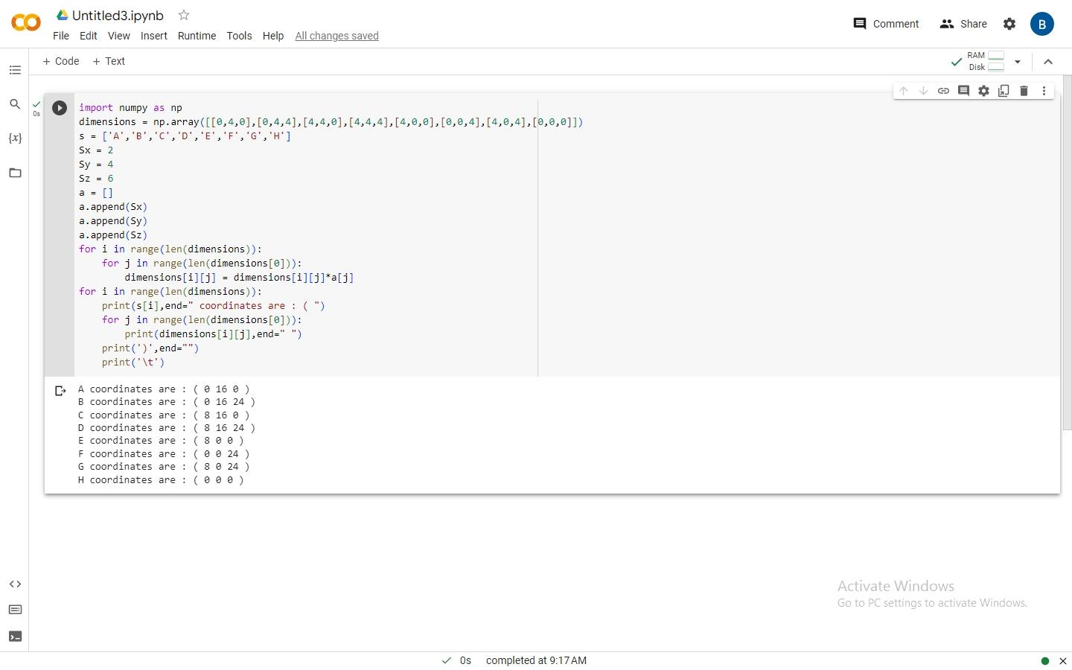**Program with output:**